What is Hermetically Sealed Compressors. Refrigeration & Air Conditioning Compressors
HVAC: Heating, Ventilation & Air-Conditioning / By Haresh Khemani / Mechanical Engineering

Hermetically Sealed Refrigeration Compressors
The hermetically sealed reciprocating compressor is widely used for the refrigeration and air conditioning applications. In all the household refrigerators, deep freezers, window air conditioners, split air conditioners, most of the packaged air conditioners, the hermetically sealed reciprocating compressor is used. The hermetically sealed reciprocating compressor is very easy to handle, and requires low maintenance. They are used with motor power requirements from 1/20 to 71/2 hp.

What is Hermetically Sealed Compressor?
In hermetically sealed compressor, the compressor and the motor are enclosed in the welded steel casing and the two are connected by a common shaft. This makes the whole compressor and the motor a single compact and portable unit that can be handled easily. The hermetically sealed compressor is very different from the traditional open type of compressors in which the compressor and the motor are different entities and the compressor is connected to the motor by coupling or belt.

Hermetically Sealed Compressor
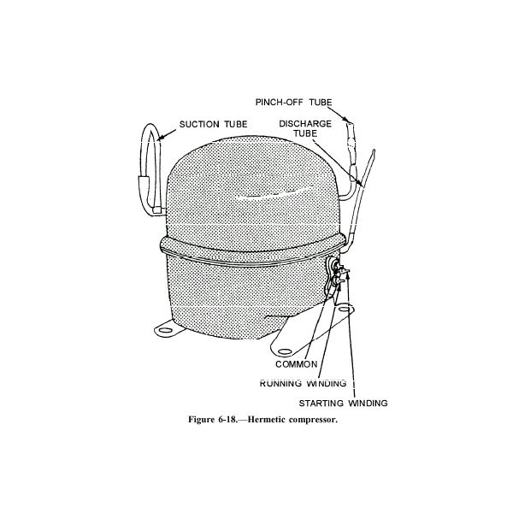
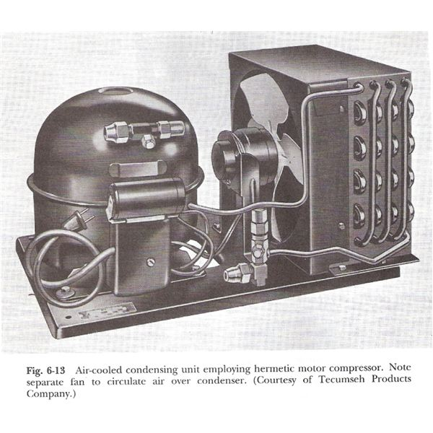
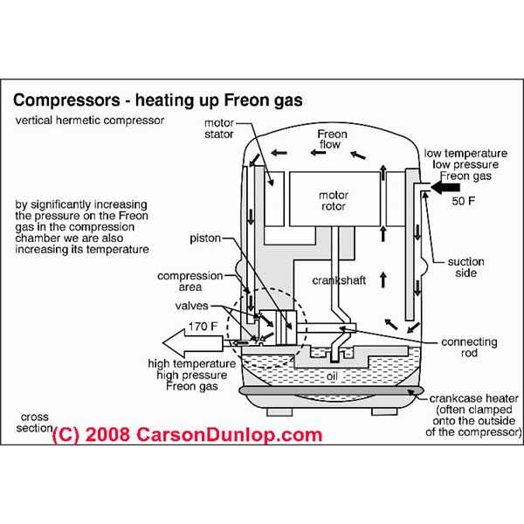
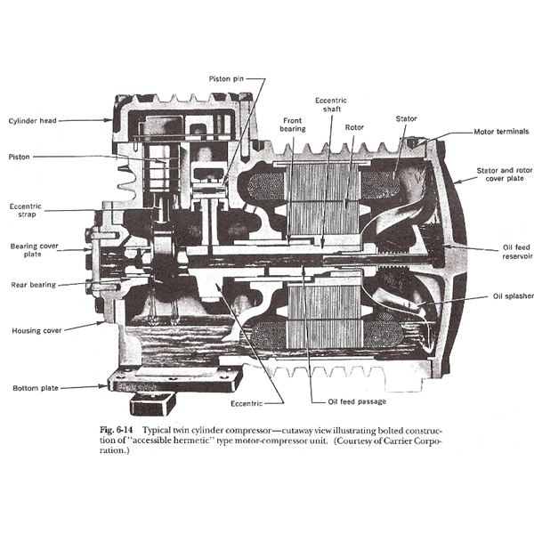
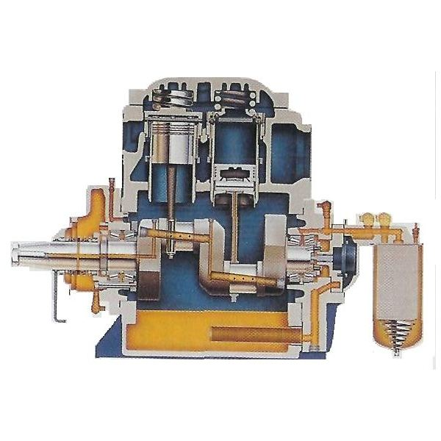

Construction of the Hermetically Sealed Reciprocating Compressor
In hermetically sealed compressor, in one side of the enclosed casing the various parts of the compressor like cylinder, piston, connecting rod and the crankshaft are located. If it is a multi-cylinder compressor, there are more than two cylinders inside the casing. On the other side of the casing is the electric winding inside which the shaft of the motor rotates. This motor can be single speed or multi-speed motor. In hermetically sealed compressors the crankshaft of the reciprocating compressor and the rotating shaft of the motor are common. The rotating shaft of the motor extends beyond the motor and forms the crankshaft of the hermetically sealed reciprocating compressor.
All these parts of the hermetically sealed compressor are assembled and enclosed in a strong and rigid casing made up of welded steel shell. The steel shell comprises of two half rounded steel bodies that are welded together to form the casing for the hermetically sealed compressor. In some cases the two halves of the shell can be bolted together instead of welding, which permits easy opening of the casing in case of compressor burnout.
The hermetically sealed compressors have inbuilt lubrication system for the lubrication of the piston and cylinder and crankshaft. The lubricant also acts the coolant for the piston and cylinder. Additionally, the cool suction refrigerant also offers cooling effect.
Externally, the casing has refrigerant suction and discharge connections that are connected to the evaporator and condenser respectively. There is also socket for the electrical connection.
The typical condenser unit with the hermetically sealed compressor is shown in above fig. Such condenser units are called as hermetic condenser units. In the other image various parts of hermetically sealed multi-cylinder reciprocating compressor are shown.

Types of Hermetic Compressors
One of the most popular types of the hermetically sealed compressors are the reciprocating compressors. They were the first to be used as the hermetically sealed compressors are still being used widely. These days the vane type of rotary compressor has become more popular. It is considered that the rotary type of hermetically sealed compressor consumes less electricity, makes lesser noise, requires lesser maintenance, and is cheaper than the reciprocating type of hermetically sealed compressor. This is because the rotary compressors has less frictional parts and have only a rotor. The centrifugal types of hermetically sealed compressor are used for the large units.

Advantages of the Hermetically Sealed Compressors
The hermetically sealed compressors are used widely in the refrigeration and air conditioning applications because of several advantages, here are some of them:
1) The hermetically compressors can be moved easily from one place to the other place, they are highly portable. One does not have to disassemble the compressor from the motor and no coupling, belt and pulley arrangement is involved.
2) The whole condenser unit of the refrigeration or the air conditioning unit comprising of the condenser and the compressor can be moved easily from one place to the other. Its location can be changed easily.
3) Since no coupling, belt or pulley is involved, the maintenance is lesser.
4) The lubrication system of the hermetically sealed compressor is inherent and no external lubrication is required, unless the fresh gas charging is done.
5) The installation of the hermetically sealed compressor is very easy. The suction and discharge connections and the electrical connections are available externally.
6) Hermetically sealed compressors have very long life, the companies offer warranty period of up to seven years for these compressors.

Disadvantages of the Hermetically Sealed Compressor
Apart from the many advantages the hermetically sealed compressor has some disadvantages, as mentioned below:
1) When the motor winding of the hermetically sealed compressor burns, the whole compressor has to be replaced. In such cases though the company gives some compensation for the old damaged compressor, still it’s a costly affair to replace the whole compressor of your household refrigerator or air conditioner. Not only you will have to replace the compressor, but fresh gas charging has to be done. In open type of compressor, if the motor winding burns, merely the winding has to be changed.
2) If any parts of the compressor like the cylinder, piston etc, gets damaged, again the whole hermetically sealed compressor has to be replaced and then one has to do fresh gas charging. In open type of compressor one can easily replace various parts of the compressor.
The various advantages offered by the hermetically sealed compressor outdo a few disadvantages that they offer. It is due to this reason that they are used so extensively in household refrigerators and wide variety of air conditioners. In fact the open type of compressors just can’t replace the hermetically sealed compressors. The companies have made mechanism offering long warranty periods for hermetically sealed compressor and their easier replacement in case of damages.

Image Courtesy
1) Principles of Refrigeration by Roy J. Dossat, Printice Hall Publications, fourth edition, page number 94 and 95.
2) https://www.inspect-ny.com/aircond/aircond02.htm
3) https://www.alpinehomeair.com/_viewresource.cfm?ID=550

